**INFERENCE**: Homework 

*Professor Regina*

Fan Yang

UNI: fy2232

# Problem 1

## (a)



So 

## (b)



# Problem 2





We estimate p by 

So an approximate confidence interval for *p*



which is 

# Problem 3

Because , 



By central limit theorem,



and , 



The confidence interval is 

or 

# Problem 4





# Problem 5

Likelihood function is



, which means 

Then the Jacobian is















Since ,



# Problem 6







The plot of  is below. significance level is 

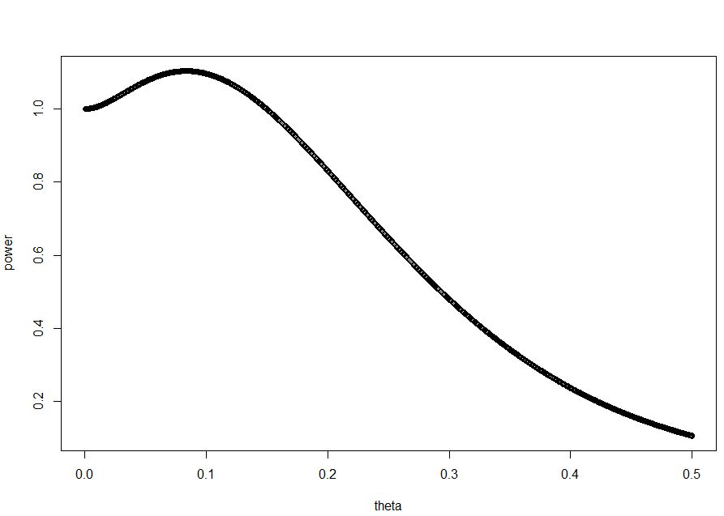

# Problem 7

## (a)





## (b)



# Problem 8







# Problem 9 (#10 on page 529)



The length of this interval is 

Then the squared length of this interval is 



# Problem 10 (#13 on page 529)

## (a)

The likelihood function is



which is also a normal distribution with mean  and variance 





Then the interval should be 

which is 

## (b)

As ,  and 

then the interval becomes , which is the same as the confidence interval of 

# Problem 11 (#22 on page 529)

## (a)



so the pdf of  is 

## (b)



## (d)



We can set  and , then 

# Problem 12 (#9 on page 622)

Use Neymann-Pearson Lemma



Size  test:



So  thus 



When  or , , so the criterion region should be modified to



The power when  is true is



# Problem 13 (#11 on page 622)

Use Neymann-Pearson Lemma



Under , 



Under , 



# Problem 14 (#12 on page 622)

Use Neymann-Pearson Lemma



Because ,  is a decreasing function of . So,



Under , , 





# Problem 15 (#13 on page 622)

Use Neymann-Pearson Lemma



Because ,  is a decreasing function of . So,

